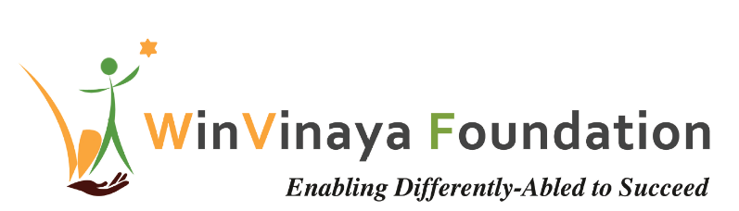

__________________________________________________

Employability Training Ideas

For Persons with Disability in Bangalore, Karnataka

Proposal for Addendum to SAMEIP Project

by

WinVinaya Foundation

To

American India Foundation

Date: 27th September 2021

Primary Contact: Sivasankar Jayagopal

Founder Chairman

WinVinaya Foundation

25/3 Brindavan 3rd Cross, Saraswathipuram

IIM Post

Bangalore 560076

Ph.: +91-96764-33359

Email: [Shiva.Jayagopal@WinVinayaFoundation.org](mailto:Shiva.Jayagopal@WinVinayaFoundation.org)

# Background

Based on the discussion that WinVinaya Foundation leaders had with leaders of AIF, we are pleased o submit this proposal for multiple Boot Camp Training programs for Persons with Disabilities that can be accomplished in 4 to 8 weeks duration along with budget requirements. This will be an addendum to the SAMEIP Project.

# Boot Camp Training Programs

**We plan to start the Boot Camp Training during the week of 27-Sep-2021** and complete it as per the training duration mentioned for each of the Boot Camps. We will be using our online learning platform – WinVinaya Academy, which is designed for Persons with Disabilities (with courses in Indian Sign Language Medium and English Medium) along with training the candidates through Online Meeting Platforms like Zoom.

## Boot Camp Training Programs

**Upskilling AIF Students in IT Skills:** There are 8 AIF students who were trained by WinVinaya Foundation in software development in Java, SQL. We are looking at upskilling them in HTML, CSS, JavaScript Basics and recap sessions in Java and SQL to make them full stack developers. **The duration of the training is 6 weeks**.

**Training PWD Graduates in IT Full Stack Development Program:** We are planning to conduct training in IT Full Stack Development which includes - HTML, CSS, JavaScript Basics, Java and SQL along with English and Soft Skills. We will train 7 candidates in this program. **The duration of the training is 12 weeks.**

**Training PWD Graduates in BPA Program:** We are planning to conduct training in Business Process Automation (BPA) covering English, Soft Skills, MS Excel, MS Word, Agile Fundamentals, SQL and Power Platform (Power BI and Power Automate) for Persons with Disabilities. As the training will follow a blended model of ONLINE TRAINING and SELF LEARNING, we will have 6 candidates for this program, split across two batches. **The duration of the training is 8 weeks.**

**Training Program for Customer Support Role:** This training covers Advanced English, MS Excel, MS Word and Power BI for Persons with Disabilities for a **duration of 4 weeks**. The number of students for this program is 10.

Our approach to train the PWD graduates in the above listed programs is as below -

* **Sourcing**: WinVinaya collaborates with colleges, NGOs, Social Media, Alumni to source the candidates. The candidates will be a combination of freshers looking for a job or experienced persons who are looking for better career growth. WinVinaya has a database of candidates who can be trained.
* **Screening**: WinVinaya will do a pre training assessment of the candidates through a combination of online aptitude/ English/ technical questions, mock interview questions to assess their knowledge levels, interests, and readiness for jobs and provide career guidance.
* **Training**: WinVinaya will train the candidates across various streams as given above. Candidates will be chosen to be trained in appropriate training based on their pre training assessment results.

We need your support in conducting the training FREE OF COST to the PWD graduates.

# Project Schedule and Budget Information

## Boot Camp Training Schedule

|  |  |  |  |  |  |  |  |  |  |  |  |  |
| --- | --- | --- | --- | --- | --- | --- | --- | --- | --- | --- | --- | --- |
| **Batch** | **Training Program** | **Training**  **Start Date** | | **Training**  **End Date** | | **# of Candidates** | **Cost** | | | | **Cost per Candidate** | **Total** |
| 1 | Upskilling AIF Students in IT Skills  **(6 Weeks Duration)** | 6-Oct-2021 | | 23-Nov-2021 | | 8 | Sourcing | | | | - | ₹ 1,34,400 |
| Training | | | | ₹ 16,800 |
| **Sub Total** | | | | | | | | | | **₹ 1,34,400/-** |
| 2 | Training PWD Graduates in IT Full Stack  **(12 Weeks Duration)** | 27-Sep-2021 | | 24-Dec-2021 | | 7 | Sourcing | | | | ₹ 2,000 | ₹ 14,000 |
| Training | | | | ₹ 33,600 | ₹ 2,35,200 |
| **Sub Total** | | | | | | | | | | **₹ 2,49,200** |
| 3-a | Training PWD Graduates in BPA Program  **(8 Weeks Duration)** | 27-Sep-2021 | | 26-Nov-2021 | | 3 | Sourcing | | ₹ 2,000 | | | ₹ 6,000 |
| Training | | ₹ 22,400 | | | ₹ 67,200 |
| **Sub Total (3-a)** | | | | | | | | | | **₹ 73,200** |
| 3-b | 18-Oct-2021 | | 17-Dec-2021 | | 3 | Sourcing | | ₹ 2,000 | | | ₹ 6,000 |
| Training | | ₹ 22,400 | | | ₹ 67,200 |
| **Sub Total (3-b)** | | | | | | | | | | **₹ 73,200** |
| 4 | Training Program for Customer Support Role  **(4 Weeks Duration)** | 15-Nov-2021 | 10-Dec-2021 | | 10 | | | Sourcing | | ₹ 2,000 | | ₹ 20,000 |
| Training | | ₹ 11,200 | | ₹ 1,12,000 |
| **Sub Total** | | | | | | | | | | **₹ 1,32,000** |
| **Total** | | | | | | | | | | | | **₹ 6,62,000** |

## Payment Schedule

Invoice will be raised after the completion of each batch and it should be paid within 30 days of Invoice date.

# Thanks for the opportunity

We thank you for giving us the opportunity to submit this proposal where we can bring a positive change in the lives of Persons with Disabilities.